Compiles construction

Assignment 2

Hamza ait messaoud

12916129

&

Michel Rummens

13108093

# Regex to NFA (using Thompson’s Construction)

We are going to generate a NFA based on the regex a(c|ab)*, but first we will split the regex in smaller automatons.

|  |
| --- |
| 1. [a] -> a(c|ab)* |
|  |
|  |
| 2. [c|ab] -> a(c|ab)* |
|  |
|  |
| 1. [(c|ab)*] -> a(c|ab)* |
|  |

We can now complete the NFA from the parts we created.

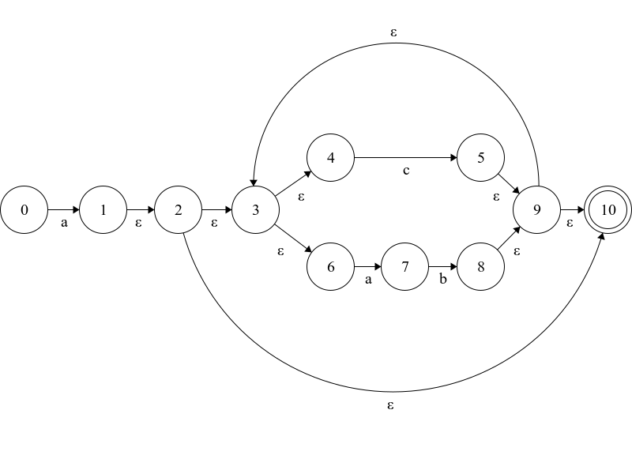

NFA to DFA (using Subset Construction)

### E-closures from states given in the NFA:

For each state in Q’, find the possible set of states for each input symbol using transition function of NFA. If this set of states is not in Q’, add it to Q’.

|  |  |
| --- | --- |
| state | e-closures |
| 0 | {0} |
| 1 | {1, 2, 3, 4, 6, 10} |
| 2 | {2, 3, 4, 6, 10} |
| 3 | {3, 4, 6} |
| 4 | {4} |
| 5 | {5, 9, 3, 4, 6, 10} |
| 6 | {6} |
| 7 | {7} |
| 8 | {8, 9, 3, 4, 6, 10} |
| 9 | {9, 3, 4, 6, 10} |
| 10 | {10} |

### Transition table

Currently, state in Q’ is q0, find moves from q0 on the input symbols using transition function of NFA and update the transition table of DFA.

|  |  |  |  |  |  |  |
| --- | --- | --- | --- | --- | --- | --- |
|  | N | states | a | a | b | c |
| -> | 0 | [0] | [1, 2, 3, 4, 6, 10] | - | - | - |
| * | 1 | [1, 2, 3, 4, 6, 10] | - | 7 | - | [5, 9, 3, 4, 6, 10] |
|  | 2 | [7] | - | - | [8, 9, 3, 4, 6, 10] | - |
| * | 3 | [5, 9, 3, 4, 6, 10] | - | 7 | - | [5, 9, 3, 4, 6, 10] |
| * | 4 | [8, 9, 3, 4, 6, 10] | - | 7 | - | [5, 9, 3, 4, 6, 10] |

### DFA-diagram:

The DFA based on the transition table

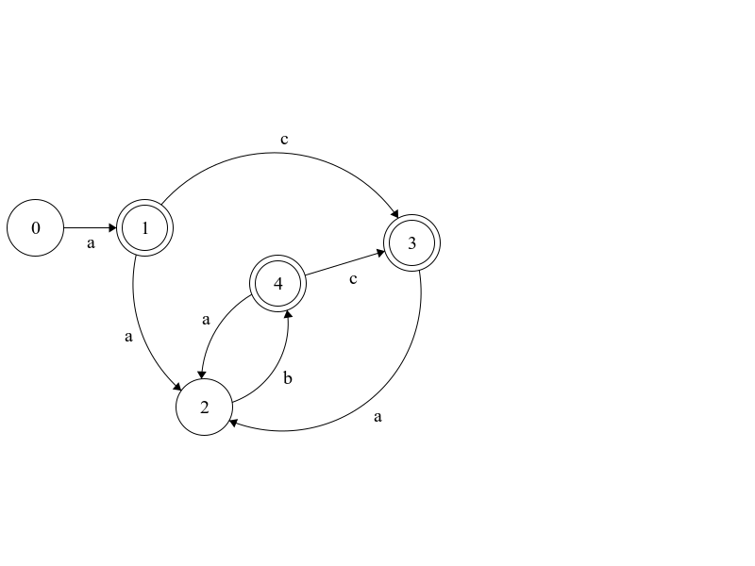

# DFA to Min DFA (based on Hopcroft’s Algorithm)

Group states that behave identically

|  |  |  |  |  |  |  |
| --- | --- | --- | --- | --- | --- | --- |
|  | N |  | a | a | b | c |
| -> | 0 | [0] | x | - | - | - |
| * | 1 | [1, 3, 4] | - | x | - | x |
|  | 2 | [2] | - | - | x | - |

### Min DFA diagram

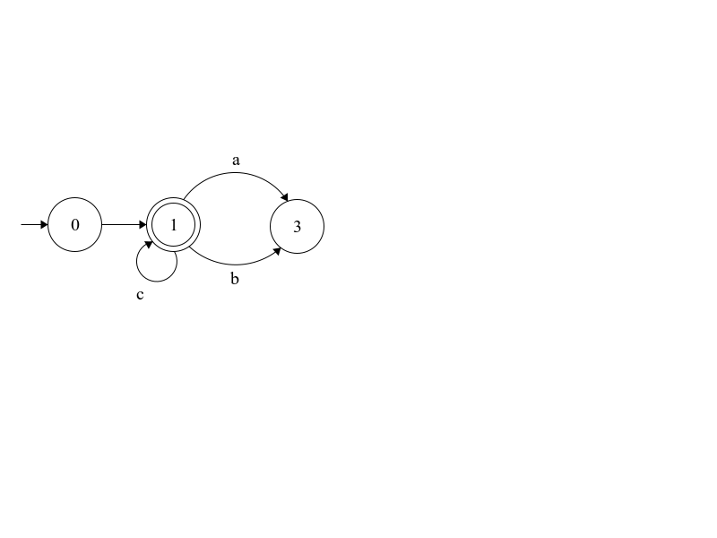

# Direct-coded Scanner

Now that we created the min-DFA we can create a DC scanner based on that data.

/**

* Scanner for the a(c|ab)* regex

*

* @param char * the string to parse

* @param int the length of the string

* @return char *|NULL

*/

char *scanner(char *stream, int pos = 0)

{

char c;

// label to scan for a character

state_init:

c = stream[pos++];

if (c == 'a') goto state_ca;

if (pos == 1) goto state_err;

else goto state_done;

// label to scan for a|ab characters recursively

state_ca:

c = stream[pos++];

if (c == 'c') goto state_ca;

else if (c == 'a') goto state_ab;

else goto state_done;

// label to scan for b character

state_ab:

c = stream[pos++];

if (c == 'b') goto state_ca;

else goto state_err;

// label to check if the end of the regex was reached

state_done:

c = stream[pos-1];

if (c == 32) goto state_succ;

else goto state_err;

// label for success

state_succ:

return stream;

// label for errors

state_err:

return NULL;

}